Contact:
B.Sc. Vanessa Schwittay
v.schwittay@sigmasoft.de
+49-241-89495-0
Kackertstr. 11
D-52072 – Aachen, Germany

Press Release

Process Optimization

SIGMA Engineering presents its Autonomous Optimization at Fakuma 2017
As the injection molding business grows in complexity and delivery times become narrower, room for mistakes shrinks. A new tool has been developed to find out the optimum design and production conditions even before the mold is built, to ensure maximum profitability and part quality. The SIGMASOFT® Autonomous Optimization finds automatically the best process set-up to meet a specific demand. At Fakuma 2017, this new technology is introduced to the interested public.
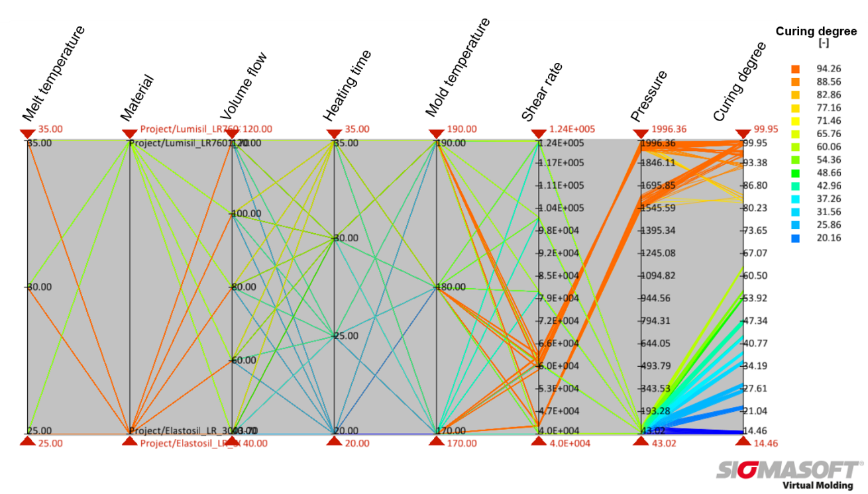
Figure 1 – With the new SIGMASOFT® Autonomous Optimization tool, the effect of process parameters and material selection on part quality can be easily assessed. The image shows all possible combinations of process parameters and material for a LSR application and their effect on the curing degree of the part.
SIGMA Engineering presents its Autonomous Optimization at Fakuma 2017

Aachen, August 2nd 2017 – At the upcoming Fakuma 2017, taking place between October 17th and 21st, SIGMA Engineering GmbH takes part in the TecPart stand at Hall A5-5105. There SIGMA introduces its new release SIGMASOFT® v5.2, which includes a virtual, fully autonomous optimization. Together with an also new virtual DoE functionality the Autonomous Optimization is a consistent further development of the SIGMASOFT® Virtual Molding technology to meet the requirements of modern injection molding.
The injection molding business has changed. The conventional trial and error solution method, or the decision making approach guided by the experience of groups of people is no longer enough to satisfy both part quality requirements and development deadlines. The room for mistakes is shrinking. Injection molders need to design their parts, molds and processes in the most efficient way, within the shortest time available. Only then they can uphold their profit margin.
SIGMA Engineering GmbH understood this challenge and, therefore, developed a new technology in their SIGMASOFT® Virtual Molding software: Autonomous Optimization. With this technology the molder can ask for a result in pretty much the same way as he would demand it from a production team. And SIGMASOFT® will automatically find the best production set-up to meet this demand.
Imagine the following scenario: you are confronted with a new molding project; a part must be assembled with other components, so that dimensional consistency must be kept within strict tolerances. The conventional approach would be to design the part and mold based on from previous experiences, build the mold and then start trials on the injection molding machine to meet the desired part dimensions. Many things can go wrong along this chain, so usually the time to find the processing window in the machine is short and the pressure high. In the best case scenario, parts are finally produced in the desired quality, but without optimizing resources such as energy consumption or cycle time.
Now the scene has changed: even while designing the part or the mold it is possible to have a virtual injection molding machine to try all modifications. And now, with the Autonomous Optimization, you can actually ask this virtual injection molding machine to solve by itself a desired problem. It is possible to ask it to minimize part deformation, for example, and the machine will “set-up” itself.
Early adopters have described the SIGMASOFT® Autonomous Optimization tool as a real “game changer” in injection molding. “This tool will change the way we produce. It will change the way we set-up new processes and the way we design our molds”, declares one of the molders which tested the potential of the new technology.
With the Autonomous Optimization, SIGMA Engineering is committed to helping its customers to systematically reduce production costs and to fully exploit the potential in the whole development chain, from part design to mold layout to process set-up.

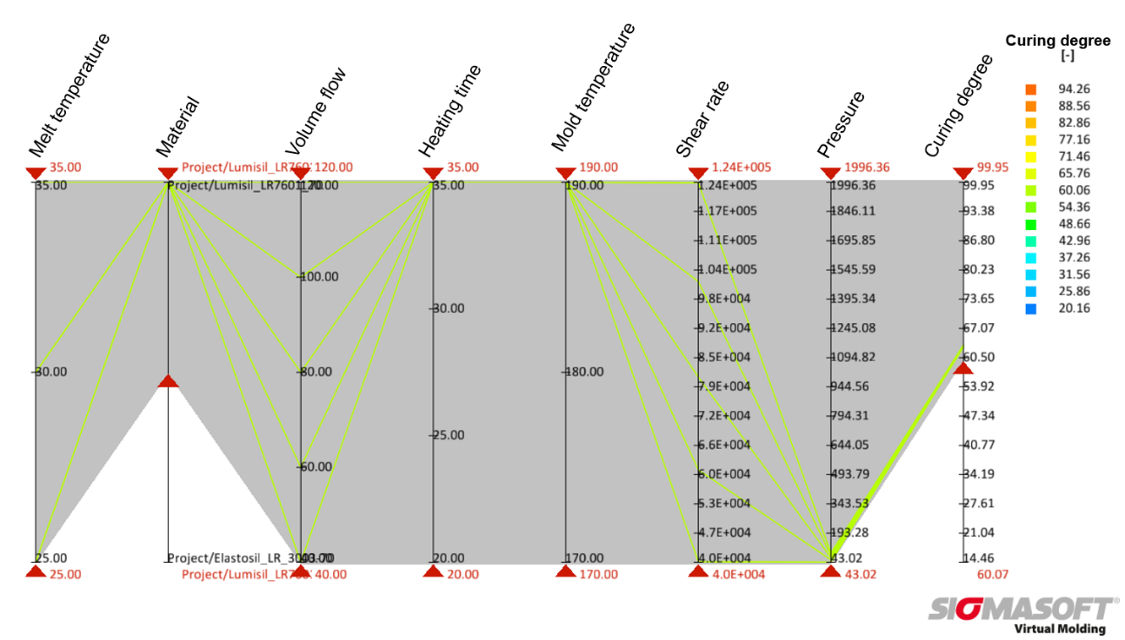
Figure 2 – In the assessment, it is easy to make further restrictions to the parameters and goals to find the optimum solution or as in the case of the LSR application the optimum process window for a specific material and a minimum required curing degree.

SIGMA® (www.sigmasoft.de) is 100% owned by MAGMA® (www.magmasoft.de), the world market leader in casting process simulation technology based in Aachen, Germany. Our SIGMASOFT® Virtual Molding technology optimizes the manufacturing process for injection molded plastic components. SIGMASOFT® Virtual Molding combines the 3D geometry of the parts and runners with the complete mold assembly and temperature control system and incorporates the actual production process to develop a turnkey injection mold with an optimized process.

At SIGMA® and MAGMA®, our goal is to help our customers achieve required part quality during the first trial. The two product lines – injection molded polymers and metal castings – share the same 3D simulation technologies focused on the simultaneous optimization of design and process. SIGMASOFT® Virtual Molding thus includes a variety of process-specific models and 3D simulation methods developed, validated and constantly improved for over 25 years. A process-driven simulation tool, SIGMASOFT® Virtual Molding provides a tremendous benefit to production facilities. Imagine your business when every mold you build produces required quality the first time, every time. That is our goal. This technology cannot be compared to any other simulation approach employed in plastics injection molding.

New product success requires a different communication between designs, materials, and processes that design simulation is not meant for. SIGMASOFT® Virtual Molding provides this communication. SIGMA® support engineers, with 450 years of combined technical education and practical experience, can support your engineering goals with applications specific solutions. SIGMA® offers direct sales, engineering, training, implementation, and support, by plastics engineers worldwide.

This press information is available to download as pdf and doc format under the following link: www.sigmasoft.de/press

