Contact:
B.Sc. Vanessa Frekers
v.frekers@sigmasoft.de
+49-241-89495-0
Kackertstr. 11
D-52072 – Aachen, Germany

Press Release

Injection Molding Processes

SIGMA Engineering presents Autonomous Optimization at Chinaplas 2018
As the injection molding business grows in complexity and delivery times become narrower, room for mistakes shrinks. A new tool has been developed to determine the optimum design of part and mold and ideal production conditions even before the mold is built, to ensure maximum profitability and part quality. The SIGMASOFT® Autonomous Optimization finds automatically the best process set-up to meet a specific demand. At Chinaplas 2018, this new technology is introduced to the Asian market.
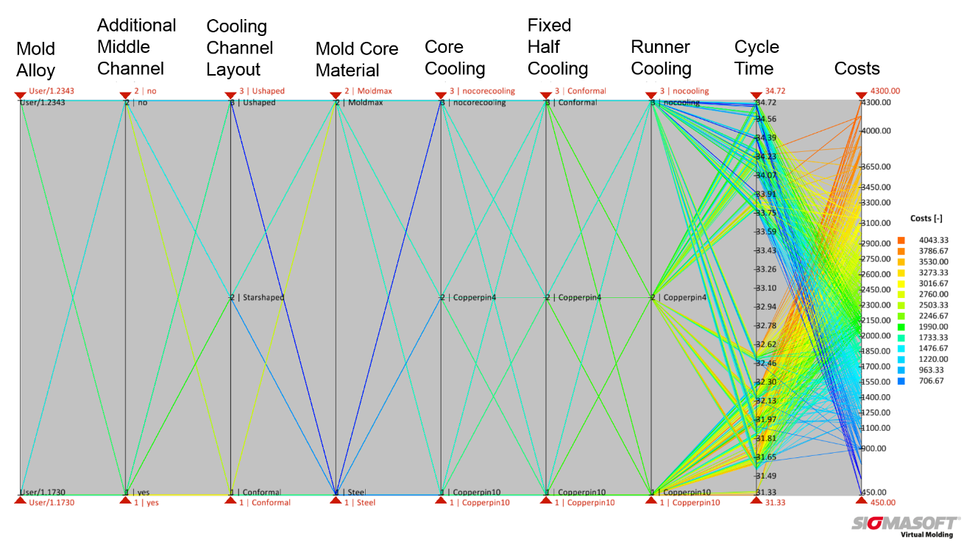
Figure 1 – With the new SIGMASOFT® Autonomous Optimization tool, the effect of cooling layout and alloy selection on cycle time and mold costs can be easily assessed. The image shows all possible combinations of mold and core alloys and cooling concepts for a thermoplastic part and their effect on mold costs.
SIGMA Engineering presents Autonomous Optimization at Chinaplas 2018

Aachen, February 1st 2018 – At the upcoming Chinaplas 2018, taking place between April 24th and 27th, SIGMA Engineering GmbH and the local SIGMA team from MAGMA Engineering Suzhou introduce at booth 5.2H C03 the new SIGMASOFT® v5.2, which includes a virtual, fully autonomous optimization. Together with an also new virtual DoE functionality the Autonomous Optimization is a consistent further development of the SIGMASOFT® Virtual Molding technology meeting the requirements of modern injection molding.
The injection molding business has changed. The conventional trial and error solution method, or the decision making approach guided by the experience of groups of people is no longer enough to satisfy both part quality requirements and development deadlines. The room for mistakes is shrinking. Injection molders need to design their parts, molds and processes in the most efficient way, within the shortest time available. Only then they can uphold their profit margin. SIGMA understood this challenge and developed a solution for molders: the Autonomous Optimization technology which is included in SIGMASOFT® Virtual Molding.
Imagine the following scenario: you are confronted with a new molding project; a part must be assembled with other components, so that dimensional consistency must be kept within strict tolerances. The conventional approach would be to design the part and mold based on previous experiences, build the mold and then start trials on the injection molding machine to meet the desired part dimensions. Many things can go wrong along this chain, so usually the time to find the processing window on the machine is short and the pressure high. In the best case scenario, parts are finally produced in the desired quality, but without optimizing resources such as energy consumption or cycle time.
Now the scene has changed: even while designing the part or the mold SIGMASOFT® Virtual Molding can be used to try all modifications. As it includes not only all geometries of part and mold, but also the full process including secondary processing times, it works as a virtual injection molding machine. And now, with the Autonomous Optimization, you can actually ask this virtual injection molding machine to solve by itself a desired problem. It is possible to ask it to minimize part deformation, for example, and the machine will “set-up” itself.
Early adopters have described the SIGMASOFT® Autonomous Optimization tool as a real “game changer” in injection molding. “This tool will change the way we produce. It will change the way we set-up new processes and the way we design our molds”, declares one of the molders which tested the potential of the new technology.
With the Autonomous Optimization, SIGMA Engineering commits itself to supporting its customers in the systematic reduction of production costs and the full exploitation of potential in the whole development chain, from part design to mold layout to process set-up.

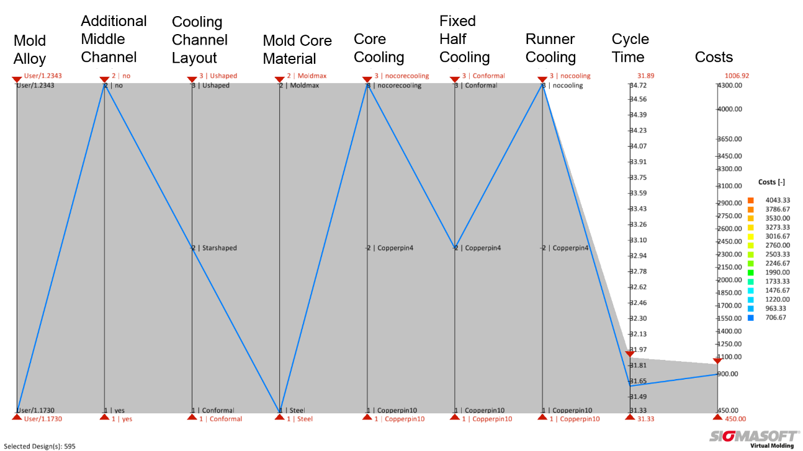
Figure 2 – In the assessment, it is easy to make further restrictions to the parameters and goals to find the optimum solution with low costs and a short cycle time

SIGMA (www.sigmasoft.de) is sister company to MAGMA (www.magmasoft.de), the world market leader in casting process simulation technology based in Aachen, Germany. Our SIGMASOFT® Virtual Molding technology optimizes the manufacturing process for injection molded plastic components. SIGMASOFT® Virtual Molding combines the 3D geometry of the parts and runners with the complete mold assembly and temperature control system and incorporates the actual production process to develop a turnkey injection mold with an optimized process.

At SIGMA and MAGMA, our goal is to help our customers achieve required part quality during the first trial. The two product lines – injection molded polymers and metal castings – share the same 3D simulation technologies focused on the simultaneous optimization of design and process. SIGMASOFT® Virtual Molding thus includes a variety of process-specific models and 3D simulation methods developed, validated and constantly improved for over 25 years. A process-driven simulation tool, SIGMASOFT® Virtual Molding provides a tremendous benefit to production facilities. Imagine your business when every mold you build produces required quality the first time, every time. That is our goal. This technology cannot be compared to any other simulation approach employed in plastics injection molding.

New product success requires a different communication between designs, materials, and processes that design simulation is not meant for. SIGMASOFT® Virtual Molding provides this communication. SIGMA support engineers, with 450 years of combined technical education and practical experience, can support your engineering goals with applications specific solutions. SIGMA offers direct sales, engineering, training, implementation, and support, by plastics engineers worldwide.

This press information is available to download as pdf and doc format under the following link: www.sigmasoft.de/press

