Contact:

B.Sc. Vanessa Frekers
press@sigmasoft.de
+49-241-89495-0
Kackertstr. 11
D-52072 – Aachen

Press Release

Improved Part Properties via Virtual DoE

SIGMASOFT® identifies ideal parts and injection processes virtually

SIGMASOFT® Virtual Molding helps to find the ideal configuration of part, mold and process in one calculation. With the new Autonomous Optimization technology and the included virtual DoE, the software helps to improve existing injection molding tools and processes as well as to virtually test different configurations and innovative approaches. In spring SIGMA Engineering showcases applications, which utilize virtual DoE for different materials, at different exhibitions.

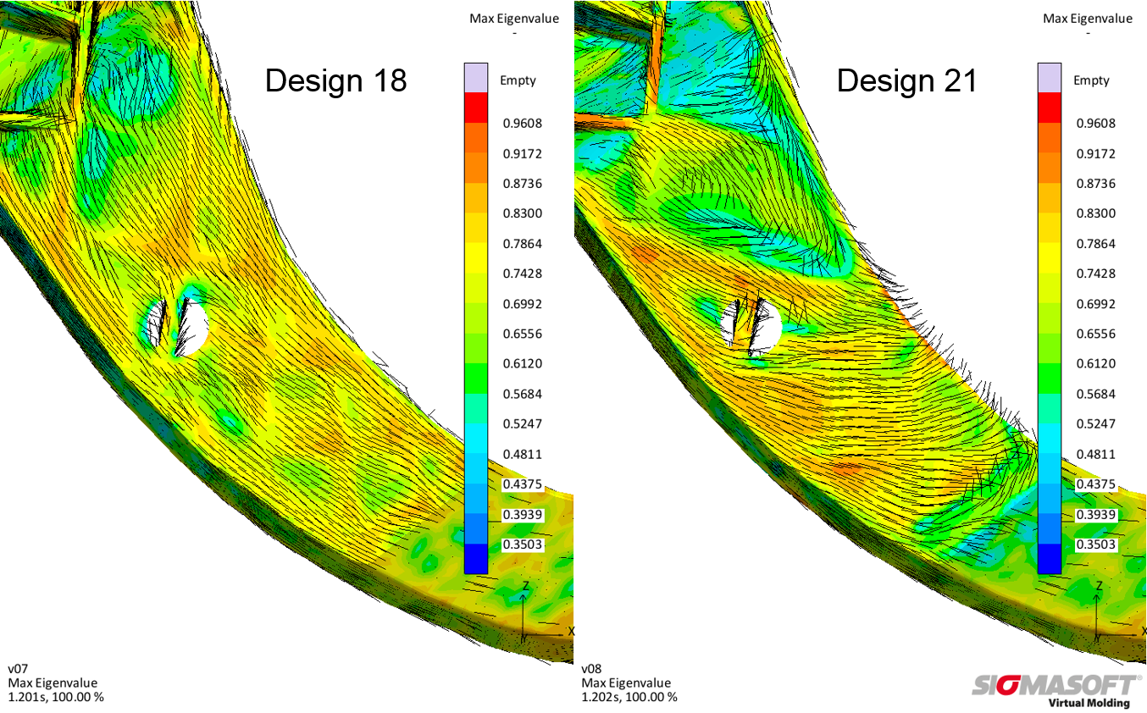
Figure 1 – The fiber orientation changes with the position of the injection point. With the help of a virtual DoE different injection positions and their resulting fiber orientation are easily compared to find the ideal set-up.
Improved Part Properties via Virtual DoE

Aachen, February 21st, 2019 – SIGMA Engineering GmbH from Aachen, Germany, introduces its SIGMASOFT® Virtual Molding software and the enclosedy Autonomous Optimization technology at various exhibitions. The Autonomous Optimization and its included possibility to conduct virtual Design of Experiments (DoE) help the user to optimize their parts, molds and processes even easier than before.
During spring SIGMA exhibits its technology around the world at the following shows:
- MECSPE in Parma, Italy, March 28th to 30th, 2019, Pad. 6 booth I39
- KUTENO in Rheda-Wiedenbrück, Germany, May 7th to 9th, 2019, hall 1 booth B15
- Chinaplas in Guangzhou, PR China, May 21st to 24th, 2019, booth 4.2A09
SIGMASOFT® works as a virtual injection molding machine and allows the user to test different set-ups and new concepts without risk on the computer. With the now included possibility to conduct a virtual DoE, different geometry and process parameter variations can be compared and evaluated in one single calculation. In this way, the user can easily answer various questions on the part and process upfront during the design stage without conducting tests on an injection molding machine.
A common type of virtual DoE, regardless of the used polymer, is the determination of the ideal injection point for the part. For fiber-reinforced thermoplastic materials, the injection point has a main influence on the resulting fiber-orientation inside the part (see Figure 1). Depending on the flow path of the melt, the fibers show a varying orientation inside the part. This leads to different mechanical properties. By determining the best injection point, the user can considerably improve the fiber-orientation and thus the mechanical properties of the part.
For rubber and LSR (liquid silicone rubber) materials, the required injection pressure is mainly depending on the gating system. To optimize the pressure loss and the whole gating system, a virtual DoE, which evaluates different positions and number of gates, is a straightforward approach. At the same time, the risk of potential air entrapments is rated (Fig. 2). Based on this first evaluation the ideal configuration of the cold runner and the optimum filling time can be determined. In the further course of the project, the design of the whole mold and its concept for the heating cartridges is supported by the software.
With the possibility to conduct a virtual DoE the user can rely on SIGMASOFT® Virtual Molding during the design of parts, molds and processes. The software provides an easy to use tool to answer questions arising on topics like ideal injection point, temperature layout of the mold or optimum cycle time. Thus, it enables the user to make decisions on a sound basis and helps to reduce trials on the machine and iterations for the mold significantly.

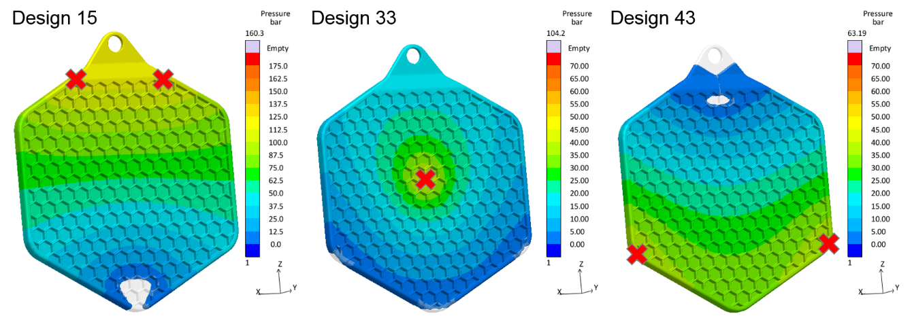

Figure 2 – With the help of a virtual DoE different injection points (red crosses) are compared regarding injection pressure and air entrapments for an LSR pot cloth. While Design 15 and 43 have a high risk of undesired air bubbles, the Design 33 combines a good filling behavior with a low pressure demand.

SIGMA (www.sigmasoft.de) is sister company to MAGMA (www.magmasoft.de), the world market leader in casting process simulation technology based in Aachen, Germany. Our SIGMASOFT® Virtual Molding technology optimizes the manufacturing process for injection molded plastic components. SIGMASOFT® Virtual Molding combines the 3D geometry of the parts and runners with the complete mold assembly and temperature control system and incorporates the actual production process to develop a turnkey injection mold with an optimized process.

At SIGMA and MAGMA, our goal is to help our customers achieve required part quality during the first trial. The two product lines – injection molded polymers and metal castings – share the same 3D simulation technologies focused on the simultaneous optimization of design and process. SIGMASOFT® Virtual Molding thus includes a variety of process-specific models and 3D simulation methods developed, validated and constantly improved for over 25 years. A process-driven simulation tool, SIGMASOFT® Virtual Molding provides a tremendous benefit to production facilities. Imagine your business when every mold you build produces required quality the first time, every time. That is our goal. This technology cannot be compared to any other simulation approach employed in plastics injection molding.

New product success requires a different communication between designs, materials, and processes that design simulation is not meant for. SIGMASOFT® Virtual Molding provides this communication. SIGMA support engineers, with 450 years of combined technical education and practical experience, can support your engineering goals with applications specific solutions. SIGMA offers direct sales, engineering, training, implementation, and support, by plastics engineers worldwide.

This press information is available to download as pdf and doc format under the following link: https://www.sigmasoft.de/en/press/

