**Contact:**

Wahid Moorad

press@sigmasoft.de

+49-241-89495-1006

Kackertstr. 16-18

D-52072 Aachen

**Press Release**

**SIGMASOFT****® at K-Show**

**New features, better quality, higher speed.**

*At K-Show 2025, SIGMA Engineering presents its new version of SIGMASOFT® Virtual Molding.*

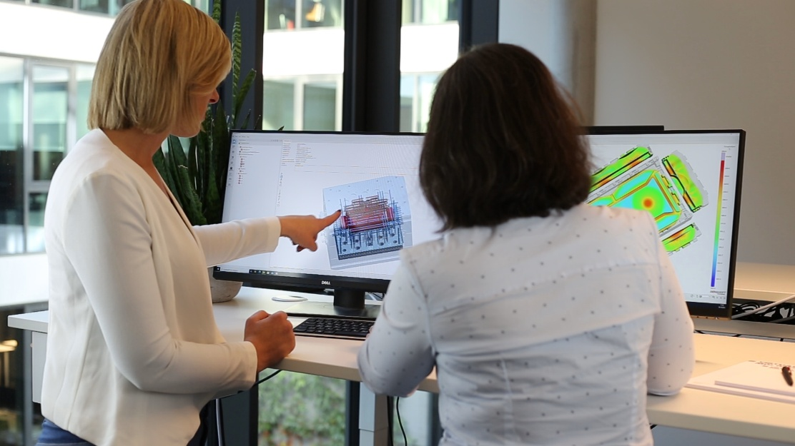

*Picture: two users showcasing SIGMASOFT****®*** *during a deep-dive of the software*

**SIGMASOFT® at K 2025**

**Aachen, Sept 9th, 2025** – At K 2025 in Düsseldorf (Oct 8-15), SIGMA Engineering GmbH will showcase the advancements of SIGMASOFT® at booth A80 in Hall 13. With the new version 6.2, more speed and quality become available, together with furtherly improved ergonomics.

The new release of SIGMASOFT features a lot of upgrades “under the hood”. Innovation of the simulation engine, together with new computational approaches, delivers higher-quality results up to four times faster than before. Further improvements of the user interface guide even casual users more smoothly to high quality simulation results.

Premiering on the K-Show are also two brand-new features: SIGMAecon and the SIGMA Rubber Designer.

Securing a contract often depends on offering an aggressive selling price. However, turning such a project into a sustainable success requires precise knowledge of one's own costs beforehand. **SIGMAecon** features the precise determination of the component costs in the currently simulated process and, its variants found with the built-in autonomous optimization process. Modified thermal concepts (such as the use of hot or cold runner technology or additional insulation) are not only considered as additional costs or material savings but, also in terms of the energy consumption for a better CO2 footprint.

The measurement of elastomers is time-consuming and cost-intensive, which is why the material data of the compounds based on measurements is only available for the simulation in a few cases. This is where the **SIGMA Rubber Designer** comes in: This generic database allows approximation of the own elastomer compound without measurement, for use in simulation, thereby obtaining realistic results swiftly and efficiently.

"For over 25 years SIGMASOFT Virtual Molding is an industry benchmark for digital reality in polymer processing" says Thomas Klein, CEO of SIGMA. "And it is well supported too. We guide our customers, train dozens of simulation experts every year, and are available every day to provide engineering assistance. We are proud to have been a sought-after partner in the plastic and rubber industry for many years."

Since 1998, SIGMA Engineering GmbH has been driving the development of the injection molding process with its simulation solution SIGMASOFT® Virtual Molding. This virtual injection molding machine enables the optimization and development of polymer components and molds as well as the mapping of the entire production process. The SIGMASOFT® Virtual Molding technology combines the part’s 3D geometry with its tooling and temperature control system and integrates the parameters of the production process. This ensures a cost-efficient and resource-saving production as well as high-performance products - from the first shot.

SIGMASOFT® Virtual Molding integrates a multitude of process-specific models including 3D simulation technologies that have been developed and validated over decades and are being continuously optimized. The SIGMA Solution Service and Development team support customers’ specific goals with application solutions. The software company SIGMA offers application engineering, training, direct sales, and support. A software straight from its developers and designers to be a solution service to polymer engineering all over Europe.

SIGMA Engineering GmbH, headed by Managing Director Thomas Klein, has subsidiaries in the USA, Brazil, Singapore, China, India, Korea, and Turkey. In addition, SIGMA supports its users worldwide in a variety of international companies and research institutions with its Virtual Molding technology.

More information: sigmasoft.de

This press information is available to download in pdf and doc format under the following link: <https://www.sigmasoft.de/en/press/>