Contact:
Wahid Moorad
press@sigmasoft.de
+49-241-89495-1006
Kackertstr. 16-18
D-52072 Aachen

Press Release

Experience Virtual Molding: Test Your Own Mold with SIGMASOFT® at FAKUMA
Aachen, August 2026 – At this year’s FAKUMA trade show, SIGMA Engineering will present the new and enhanced SIGMASOFT® Virtual Molding. The latest version, 6.2, features numerous enhancements that make virtual molding results even more realistic. At the same time, improved efficiency and new calculation models significantly reduce simulation times.

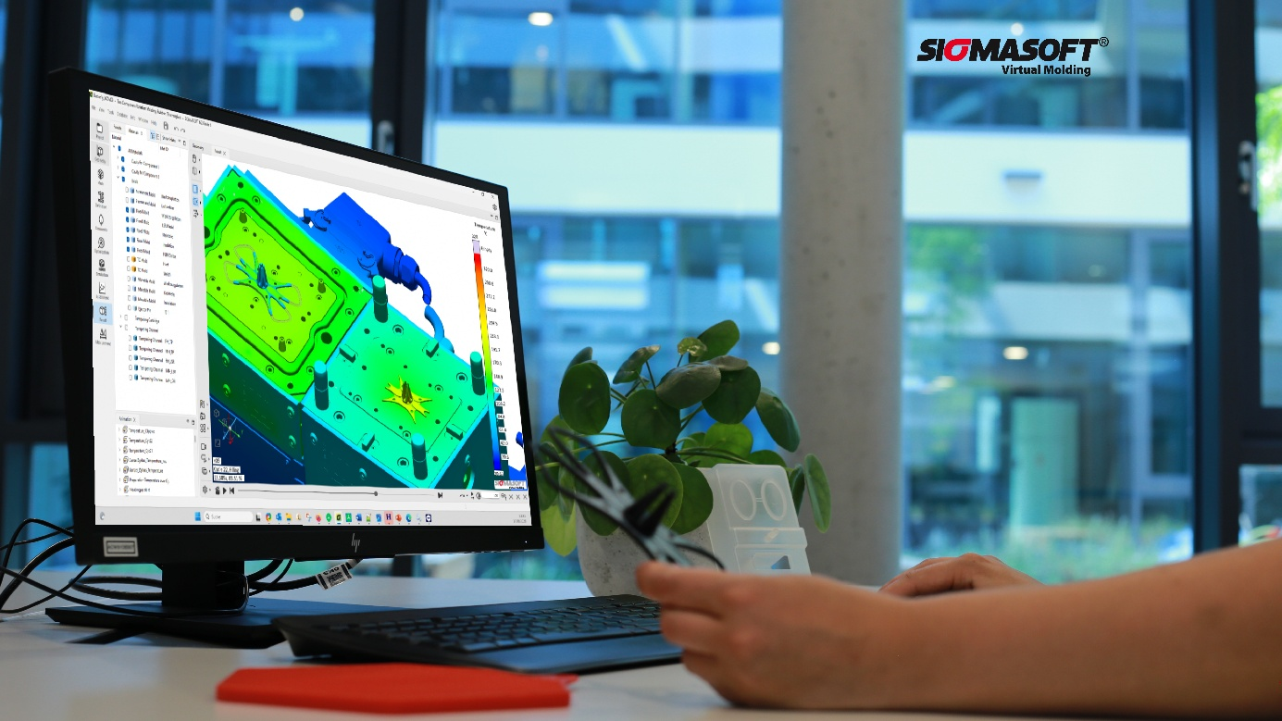Figure 1: SIGMASOFT® 6.2 live at FAKUMA

A particular highlight is the interactive, hands-on presentation of SIGMASOFT®. Instead of test geometries, hypothetical tools, or videos, the focus is on the actual challenge faced by each individual visitor. In around half an hour, the simulation model is set up based on the geometry data of a new or existing mold or part – for example, from a current customer inquiry – right up to the start of the simulation. Visitors can see for themselves how SIGMASOFT® automatically meshes the complete mold geometry and creates the simulation model, including the assigned material data.
Based on an article or mold geometry, potential manufacturing problems or precise process data for cost calculation can then be determined quickly. This allows to evaluate how closely the simulation matches verifiable real-world results – for example, in terms of shrinkage and warpage – and to carry out simulated optimizations.
Visitors can quickly understand what state-of-the-art injection molding simulation can mean for their own applications. Getting immediate solutions to their own challenges is more practical than first discussing what the software can theoretically do.
Of course, an appointment must be arranged in advance. Ideally, the relevant geometries should also be submitted as .stp files beforehand to ensure that all the necessary data is available. This can easily be done at https://www.sigmasoft.de/en/about-us/events/FAKUMA-2026/. All discussions, data, and results are, of course, handled personal and confidential.
“The fact that visitors can now practically bring their own injection mold to the trade fair for a trial run is something new!” says Thomas Klein, Managing Director of SIGMA. “Our experts will be on site, and we look forward to engaging in exciting discussions and challenging applications.”

Since 1998, SIGMA Engineering GmbH has been driving improvements in the injection molding process with its SIGMASOFT® Virtual Molding simulation solution. This virtual injection molding software enables the optimization and development of plastic components and molds, as well as the simulation of the entire process control. This is because SIGMASOFT® Virtual Molding technology combines the 3D geometries of the part with the mold and temperature control system and integrates the parameters of the production process. This enables cost-efficient, resource-saving production and high-performance products—right from the first shot.
SIGMASOFT® Virtual Molding integrates a wide range of process-specific models and 3D simulation technologies that have been developed and validated over decades and are continuously optimized. The SIGMA solution and development team supports customers’ technical goals with application-specific solutions. The software company SIGMA offers direct sales, application engineering, training, installation, and a Solution Service provided by engineers throughout Europe.
With subsidiaries of its sister companies in the USA, Brazil, Singapore, China, India, Korea, and Turkey, SIGMA supports users worldwide in a wide range of international companies and research institutions with its Virtual Molding technology.
Further information: sigmasoft.de

This press release is available for download in PDF format at the following link: https://www.sigmasoft.de/en/about-us/press/

