Contact:

Katharina Aschhoff, M.Sc.
press@sigmasoft.de
+49-241-89495-1008
Kackertstr. 16-18
D-52072 Aachen

Press release

Simulation preciously applied

„The Precious“ as a public attraction of Fakuma 2023

As with every Fakuma, there are highlights for visitors that lead to long queues in the halls. One particular example of this can be found at the Arburg booth in hall A3, where the versatile dustproof and splash-resistant multifunctional box 'The Precious' is showcased. It was developed and brought to life by the elastomer expert RICO. The large two-component part made of PBT and self-bonding LSR was realized with help of SIGMASOFT®.

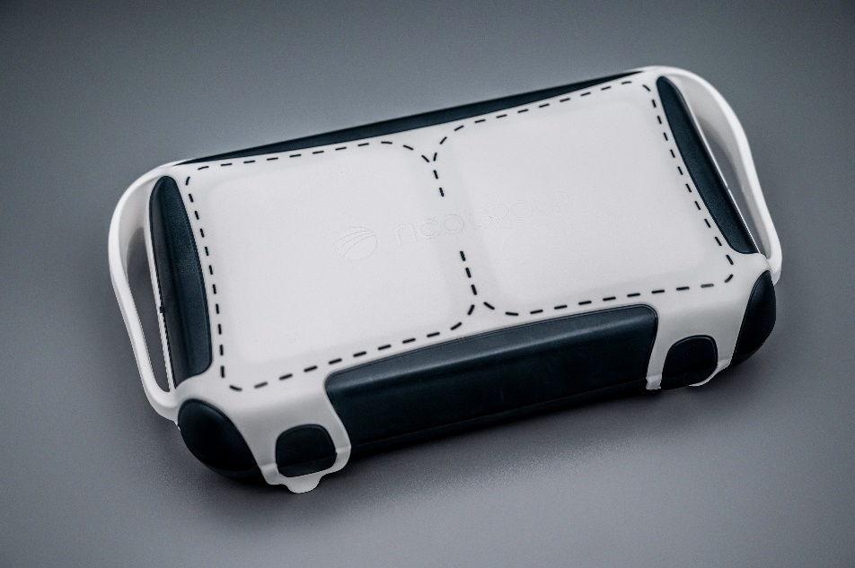

Figure 1 – „The Precious“ ready to use after molding (ref: Rico)
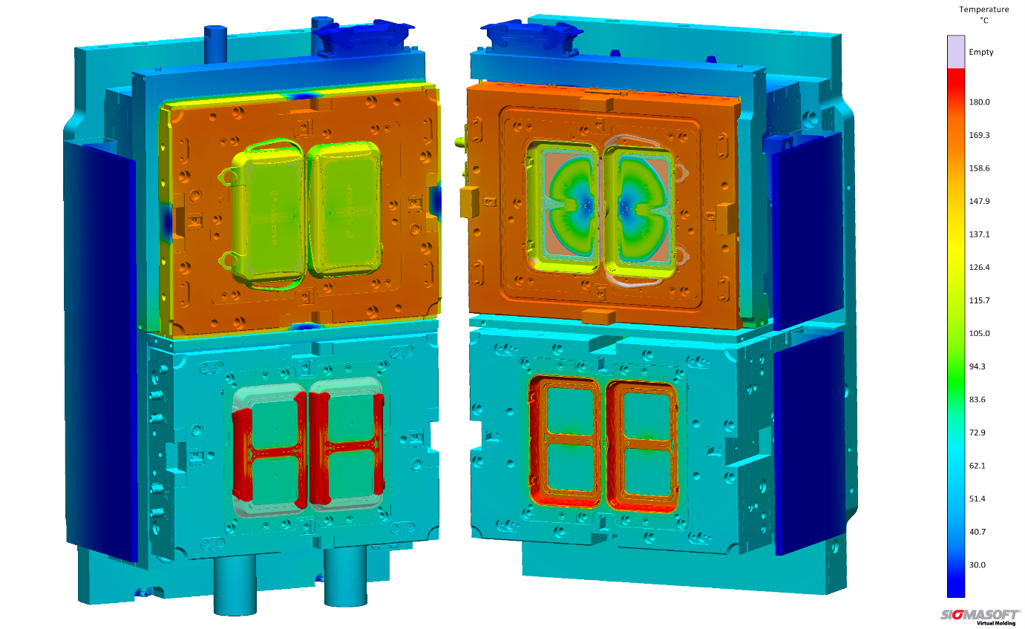
Figure 2 - „The Precious“ during Virtual Molding, bottom left filling of thermoplastic and upper right the LSR component (Source: Sigmasoft)

Simulation preciously applied
Aachen, October 13th, 2023 – At FAKUMA in Friedrichshafen (October 17-21, 2023), you can once again see several applications running on injection molding machines that were realized with the help of the simulation software SIGMASOFT®. Visitors at the Arburg booth in Hall A3 will take home a particularly valuable memento. The two-component mold was developed by RICO as a result of a Design Thinking workshop at the University of Arts in Linz. To realize such a complex component, a wealth of experience is required. For example the quality of the LSR overmolding becomes a risk due to process- and material-dependent shrinkage and warpage of the simultaneously injected plastic part.
SIGMASOFT®, well-known for simulation of polymer processing, was used here to design the entire process in detail. This includes ensuring a homogeneous temperature distribution with an optimal energy balance. Also, various plastics were virtually examined for their suitability with SIGMASOFT® Virtual Molding. This allowed for precise adaptation of the cavity for the soft component to the inserted plastic part, eliminating flash and any post-processing of finished part or changes of the mold.
In Hall A5, the experts from RICO (Booth 5004) and SIGMA Engineering (Booth 5110) are available for further discussions with visitors regarding molds and simulations. Here, you can also find suitable flexible LSR inlays to customize "The Precious" even more according to your own preferences. The inlay is also the example with which the new SIGMA Economics, a part of SIGMASOFT® 6.1, is demonstrated. SIGMA Economics allows for the calculation of component costs, change costs, and potential savings.
"A reliable calculation determines the economic success of a component even before the project starts," says Thomas Klein, Managing Director of SIGMA. "But this applies not only to the simulation-based design of new molds but also to the reliable calculation of production costs, depending on process parameters and raw materials. We are proud to have been a part of this successful development."

Since 1998, SIGMA Engineering GmbH has been driving the development of the injection molding process with its simulation solution SIGMASOFT® Virtual Molding. This virtual injection molding machine enables the optimization and development of polymer components and molds as well as the mapping of the entire production process. The SIGMASOFT® Virtual Molding technology combines the parts 3D geometries with its tooling and temperature control system and integrates the parameters of the production process. This ensures a cost-efficient and resource-saving production as well as high-performance products - from the first shot.
SIGMASOFT® Virtual Molding integrates a multitude of process-specific models including 3D simulation technologies that have been developed and validated over decades and are being continuously optimized. The SIGMA Solution Service and Development team support customers specific goals with application solutions. The software company SIGMA offers application engineering, training, direct sales and support. A software straight from its developers and designers to be a solution service to polymer engineering all over Europe.
SIGMA Engineering GmbH, headed by Managing Director Thomas Klein, has subsidiaries in the USA, Brazil, Singapore, China, India, Korea and Turkey. In addition, SIGMA supports its users worldwide in a variety of international companies and research institutions with its Virtual Molding technology.
More information: sigmasoft.de

This press information is available to download as pdf and doc format under the following link: https://www.sigmasoft.de/en/press/

