Contact:

Katharina Aschhoff, M.Sc.
press@sigmasoft.de
+49-241-89495-1008
Kackertstr. 16-18
D-52072 Aachen

Press release

SIGMA technical talks

Great response to the new series of events

The web-seminar-series that informs about the potentials and applications of modern injection molding simulation. Exclusive presentations by many partners provide a deep insight into the numerous branches of the injection molding industry.

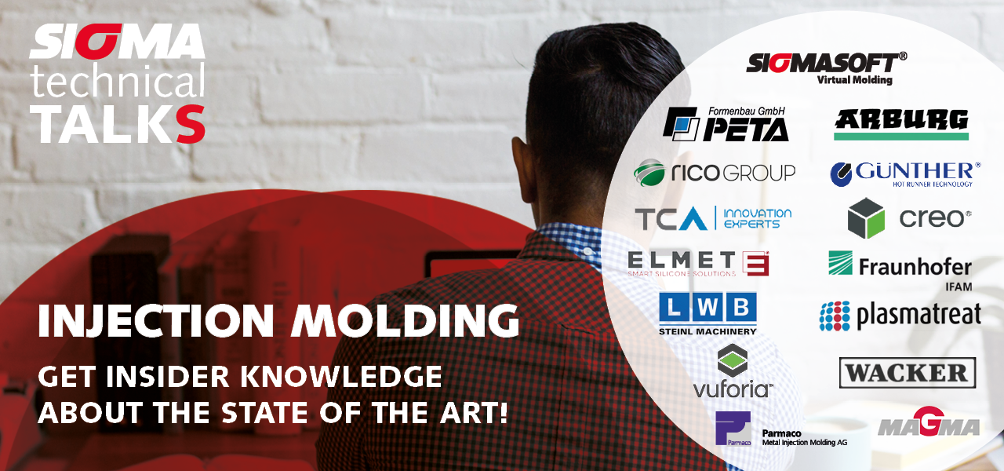
Figure 1 – web-seminar-series „SIGMA technical talks“

SIGMA technical talks

Aachen, February 12th, 2021 – In cooperation with leading industry-partners, Sigma Engineering hosts online seminars about the areas Elastomer, LSR, MIM and of course Thermoplastics in the coming weeks. The about two hour events are not focusing on SIGMASOFT® Virtual Molding but offer new technical presentations from the different value chains.
„We are happy to receive this great feedback on the planned events through several hundred of registrations so far“, says Thomas Klein, MD of Sigma. „The topics are fresh and versatile. The presenting experts are really speaking live and are available for questions after the sessions.“
More delegates to these free of charge events are welcome and can sign in at www.sigmasoft.de

For 22 years, SIGMA Engineering GmbH has been driving the development of the injection molding process with its simulation solution SIGMASOFT® Virtual Molding. This virtual injection molding machine enables the optimization and development of plastic components and molds as well as the mapping of the entire production process. The SIGMASOFT® Virtual Molding technology combines the parts 3D geometries with its tooling and temperature control system and integrates the parameters of the production process. This ensures a cost-efficient and resource-saving production as well as high-performance products - from the first shot.
SIGMASOFT® Virtual Molding integrates a multitude of process-specific models including 3D simulation technologies that have been developed and validated over decades and are continuously optimized. The SIGMA Solution Service and Development team supports its customers technical goals with application-specific solutions. The software company SIGMA offers application engineering, training, direct software sales and as a result, a software straight from its developers and designers to help give a solution service by engineers worldwide.
The SIGMA Engineering GmbH was founded in Aachen in 1998, and is now under the guidance of Managing Director Thomas Klein represented throughout Europe. With subsidiaries in Chicago, Brazil, Singapore, China, India, Korea and Turkey, SIGMA supports users in a large number of international companies and research institutions worldwide with its Virtual Molding technology.
Further information: sigmasoft.de

This press information is available to download as pdf and doc format under the following link: https://www.sigmasoft.de/en/press/

