Contact:

Katharina Aschhoff, M.Sc.
press@sigmasoft.de
+49-241-89495-1008
Kackertstr. 16-18
D-52072 Aachen

Press release

Optimizing Cycle Time with Conformal Cooling

Mold inserts from the 3D printer with optimal cooling - developed with simulation

A stable temperature in the mold is fundamental for a robust process and high component quality. At FAKUMA, SIGMA Engineering demonstrates the simulation-guided design of tempering systems using SIGMASOFT®. Using an example from /H&B/ ELECTRONIC, the optimized cooling channel manufactured by metal 3D printing is presented.

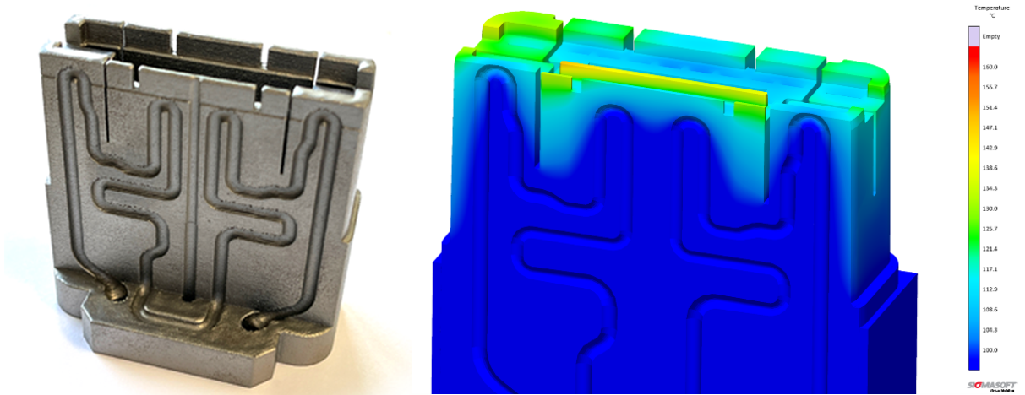

Picture 1 – Simulation and Reality - The mold insert (shown here in cross-section) had to prove itself in SIGMASOFT® Virtual Molding before manufacturing.

Aachen, September 19, 2023 – At FAKUMA in Friedrichshafen (October 17-21, 2023), SIGMA Engineering GmbH will present an example from /H&B/ ELECTRONIC created with SIGMASOFT® in Hall A5, Booth 5110. The project demonstrates how the development of conformal cooling for a connector housing is enabled and optimized through simulation.
Fundamentally, in injection molding, part quality and cycle time are significantly influenced by the thermal performance of the mold. Temperature variations lead to different cooling rates and result in residual stresses and warping in the finished part. Variations in wall thickness within the part are problematic as localized cooling requirements differ greatly. The goal is to keep temperature as homogeneous as possible, ensuring even heat dissipation. Here, conformal cooling is increasingly being utilized. Simulation allows for quantifying the advantages compared to conventional concepts (improved part quality, shorter cycle time, accurate prediction of hotspots, etc.) beforehand, in order to weigh them against additional costs.
Modern metal 3D printing allows almost free choice of shape for the mold inserts with integrated cooling – independent of the feasibility of milling, drilling, assembling, and sealing. /H&B/ ELECTRONIC has designed the simulation-based layout of this innovative 3D-printed tempering system using SIGMASOFT® and successfully implemented it into serial production.
"This is how it should always be... Thanks to the 3D-printed tempering system, it was possible to save costs and energy while simultaneously improving quality," says CTO Timo Gebauer about the project's success, adding, "We are always delighted when SIGMASOFT® enables innovations for our customers. In the case of H&B, even the significant investment in their own metal 3D printer was justified."

Since 1998, SIGMA Engineering GmbH has been driving the development of the injection molding process with its simulation solution SIGMASOFT® Virtual Molding. This virtual injection molding machine enables the optimization and development of polymer components and molds as well as the mapping of the entire production process. The SIGMASOFT® Virtual Molding technology combines the parts 3D geometries with its tooling and temperature control system and integrates the parameters of the production process. This ensures a cost-efficient and resource-saving production as well as high-performance products - from the first shot.
SIGMASOFT® Virtual Molding integrates a multitude of process-specific models including 3D simulation technologies that have been developed and validated over decades and are being continuously optimized. The SIGMA Solution Service and Development team support customers specific goals with application solutions. The software company SIGMA offers application engineering, training, direct sales and support. A software straight from its developers and designers to be a solution service to polymer engineering all over Europe.
SIGMA Engineering GmbH, headed by Managing Director Thomas Klein, has subsidiaries in the USA, Brazil, Singapore, China, India, Korea and Turkey. In addition, SIGMA supports its users worldwide in a variety of international companies and research institutions with its Virtual Molding technology.
More information: sigmasoft.de

This press information is available to download as pdf and doc format under the following link: https://www.sigmasoft.de/en/press/

