Contact:

Katharina Aschhoff, M.Sc.
press@sigmasoft.de
+49-241-89495-1008
Kackertstr. 16-18
D-52072 Aachen

Press release

Simulation and Communication

SIGMAinteract® Presents Simulation Results Interactively

The presentation of results has evolved over the past decades from tables to graphics and further to animations and videos. However, all these techniques only allow the recipient to observe and, at most, rewind and fast forward. When it comes to illustrating technically complex content, conventional tools reach their limits. To make simulation results from SIGMASOFT® even more tangible, the freeware tool SIGMAinteract® was developed.

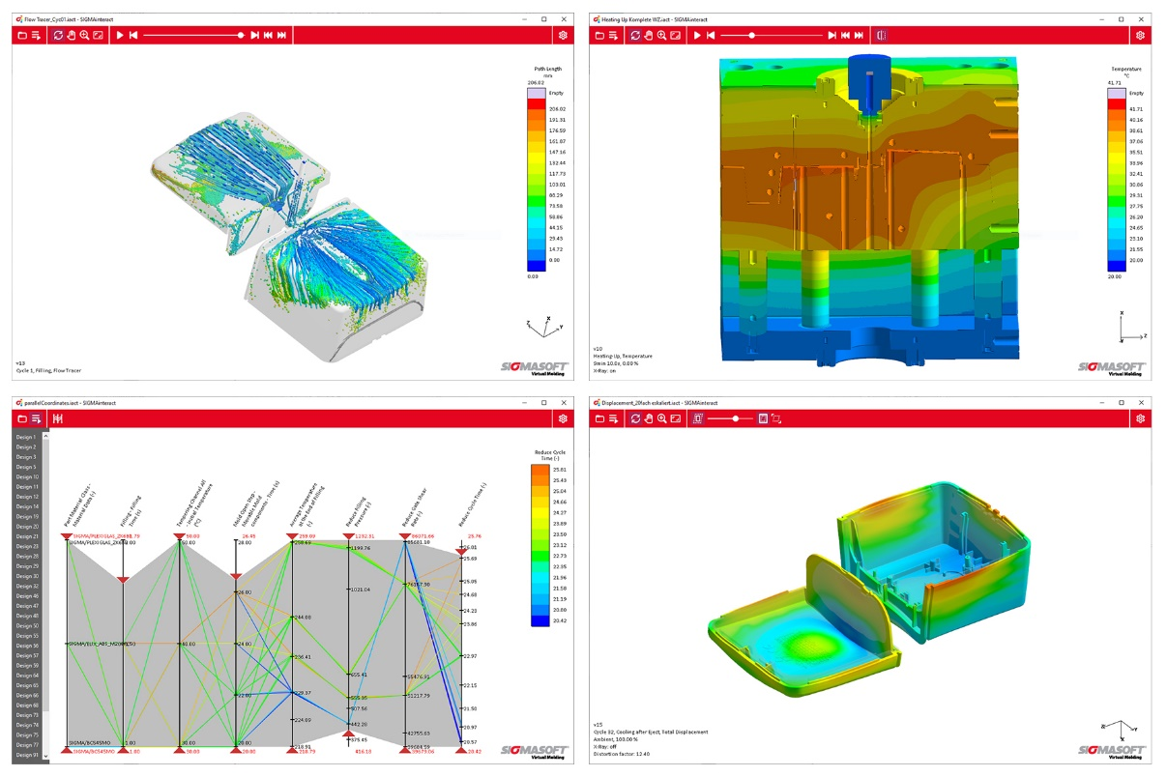
Picture 1 – Various simulation results presented using SIGMAinteract®. From top left to bottom right: tracer particles, complete tool, parallel coordinates chart, and warpage

Simulation and Communication

Aachen, August 30th, 2023 – At FAKUMA in Friedrichshafen (October 17-21, 2023), SIGMA Engineering GmbH will showcase not only a sneak peek into the upcoming SIGMASOFT® 6.1 version set to release by year-end, but also the latest freeware tool, SIGMAinteract®.
Known as a prominent simulation suite for polymer processing, SIGMASOFT® offers profound insights into polymer shaping. However, the results and details are typically visible only to experts at their workstations and not where discussions and implementation need to take place. This often occurs in meeting rooms, different buildings, with mold makers, or with clients. To prepare all these results for discussion, screenshots and videos are commonly created, but these are static and limited to the selected perspectives.
With SIGMAinteract®, the results from Virtual Molding can be directly manipulated on one's own PC, without requiring an installation or license for SIGMASOFT®. This enables the entire cycle to be rewound and fast-forwarded from various viewpoints. Thermal issues, flow defects, fiber orientations, and much more can be precisely tracked. The outcome of an experimental plan can be evaluated, such as for optimizing material selection or cycle time. The new version of SIGMAinteract® now also includes an interactive representation of shrinkage and warpage. Using the mouse, the perspective can be changed, zoomed, and elements can be toggled on and off.
The evaluation takes place independently of the simulation software license. The only requirement is that a ".iact" file must be exported from SIGMASOFT® with the desired result and then shared.
"Effective communication is the key to success," says Timo Gebauer, CTO of SIGMA. "The more efficiently a complex situation can be visualized, the faster problems can be solved with internal and external partners, and projects become economically successful. SIGMAinteract® is more powerful than screenshots and videos. It brings simulation from the CAE department to your own PC, allowing you to understand the calculations from your perspective and at your own pace."
Details and Download: www.sigmasoft.de/en/support/interact/

Since 1998, SIGMA Engineering GmbH has been driving the development of the injection molding process with its simulation solution SIGMASOFT® Virtual Molding. This virtual injection molding machine enables the optimization and development of polymer components and molds as well as the mapping of the entire production process. The SIGMASOFT® Virtual Molding technology combines the parts 3D geometries with its tooling and temperature control system and integrates the parameters of the production process. This ensures a cost-efficient and resource-saving production as well as high-performance products - from the first shot.
SIGMASOFT® Virtual Molding integrates a multitude of process-specific models including 3D simulation technologies that have been developed and validated over decades and are being continuously optimized. The SIGMA Solution Service and Development team support customers specific goals with application solutions. The software company SIGMA offers application engineering, training, direct sales and support. A software straight from its developers and designers to be a solution service to polymer engineering all over Europe.
SIGMA Engineering GmbH, headed by Managing Director Thomas Klein, has subsidiaries in the USA, Brazil, Singapore, China, India, Korea and Turkey. In addition, SIGMA supports its users worldwide in a variety of international companies and research institutions with its Virtual Molding technology.
More information: sigmasoft.de

This press information is available to download as pdf and doc format under the following link: https://www.sigmasoft.de/en/press/

